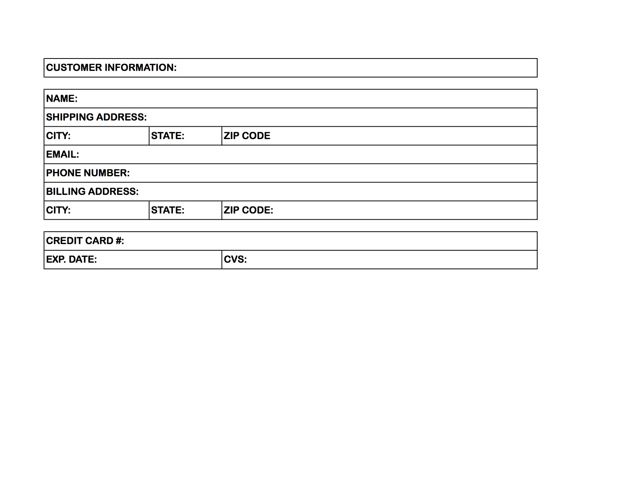

***Call Before Processing:***

***Check Box Below***

***(***

|  |  |
| --- | --- |
| Yes- | No- |

|  |  |
| --- | --- |
| Date: | Transaction #: |
| Shipping Store Name: | |
| Associate Name: | |

*TO BE COMPLETED BY FULFILLING ASSOCIATE*

**PURCHASE TOTAL: _________________________________________**

(Sales tax will be added. Percentage reflects rate of recipient’s state)

**CUSTOMER SIGNATURE: ____________________________________**

Exchanges & Store Credit: Within 30 days from purchase date, unworn product will be accepted for store credit only. Must have receipt. Color Bar™ designs are final sale. All clearance items are final sale. All birthday discounts are final sale.

|  |  |  |  |
| --- | --- | --- | --- |
| **Item Name** | **Color** | **Quantity** | **Price** |
|  |  |  |  |
|  |  |  |  |
|  |  |  |  |
|  |  |  |  |
|  |  |  |  |
|  |  |  |  |
|  |  |  |  |

**UPS SHIPPING SERVICE**

* Standard ground, 5-7 business days (No charge)
* 2-Day ($15.00)
* Overnight ($40)

**PURCHASE INFORMATION:**

**CUSTOMER INFORMATION:**

*special event phone order form*